**A**

**PROJECT REPORT ON**

# FOOD WASTE MANAGEMENT SYSTEM

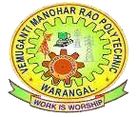

SUBMITTED IN PARTIAL FULFILMENT OF THE REQUIREMENTS FOR THE AWARD OF

**DIPLOMA IN COMPUTER ENGINEERING**

**SUBMITTED BY**

**M.SAI PRASANNA 20090-CM-047**

**S.MANISH 20090-CM-007**

**R. MRUDULA 20090-CM-012**

**T.TEJPAUL 20090-CM-025**

**D. TEJASWI 20090-CM-031**

**K. SHIVAKRISHNA 20090-CM-037**

**N. PRAGNA 20090-CM-043**

**M. BHAVANI 20090-CM-053**

**K. SRIKANTH 20090-CM-055**

**Under the valuable guidance of**

**Mrs. K. LAVANYA, B. Tech**

**DEPARTMENT OF COMPUTER ENGINEERING**

# VEMUGANTI MANOHAR RAO POLYTECHNIC

**Rampur, Warangal (TS)-506151.**

## VEMUGANTI MANOHAR RAO POLYTECHNIC

**(Sponsored by Manohara Educational Society)**

**Rampur, Warangal (T.S.)-506 151**

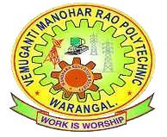

# CERTIFICATE

This is to certify that the project entitled “**FOOD WASTE MANGEMENT SYSTEM**” is carried out by **M.SAI PRASANNA (20090-CM-047)**, in partial fulfilment of the requirement for DIPLOMA IN COMPUTER ENGINEERING, by the **State Board of Technical** **Education & Training (TS), Hyderabad**, is an award of bonafide work carried out by them under our guidance and supervision. The results embodied in this project report have not been submitted to any other institutions for the award of Diploma.



**PROJECT GUIDE: HEAD OF DEPARTMANT:**

**Mrs. K. LAVANYA (B. Tech) Mr. B. VENKANNA (M. Tech)**

**EXTERNAL EXAMINER: PRINCIPAL:**

**Dr. P. YELLAIAH (M. Tech, Ph. D)**

**DECLARATION**

We declare that the work reported in the present entitled**” FOOD WASTE MANGEMENT SYSTEM”**is record of work done in the Department of Computer Engineering, **VMR Polytechnic**, affiliated to **SBTET, Hyderabad** and **AICTE, NEW DELHI.** The result of the work has not been submitted to any university or any other institution for the award of any degree.

**SUBMITTED BY**

**M.SAI PRASANNA 20090-CM-047**

**S.MANISH 20090-CM-007**

**R. MRUDULA 20090-CM-012**

**T.TEJPAUL 20090-CM-025**

**D. TEJASWI 20090-CM-031**

**K. SHIVA KRISHNA 20090-CM-037**

**N. PRAGNA 20090-CM-043**

**M. BHAVANI 20090-CM-053**

**K. SRIKANTH 20090-CM-055**

## ACKNOWLEDGEMENT

We wish to express our heartfelt gratitude to **Sri. Dr. P.Yellaiah, Principal of**  **VEMUGANTI MANOHAR RAO POLYTECHNIC,** Rampur, Warangal for providing all the facilities required for the seminar presentation.

We wish to take opportunity to express our sincere thanks to **Sri. B.Venkanna,** **H.O.D. of Computer Engineering Department** for the interest technical support and suggestions during the seminar leading to our success.

We are obliged and grateful to our guide **Mrs. K. LAVANAYA, Lecturer in Computer Engineering Department** for her valuable suggestion and sagacious guidance in all aspects during the technical of our training.

We hereby express our sincere thanks regards to all teaching staff and nonteaching staff, parents and friends who extended their helping hand in the accomplishment of the project.

# ABSTRACT

In recent times, food wastage is increasing at an unprecedented rate and creating effect on the economic growth factors. This in turn creates a major impact on the agricultural processing industries. As food recycling is always remaining as a complex task, in this paper, we are focusing mainly on the food wastage measurement system in the office premises, where it provides real-time input on the wastage of the food to the employee on a live computer-based dashboard. This research work focuses mainly on the integration of the multiple locations present in the office premises.

With this the proposed model, we can analyse and generate comparison reports to deliver a detailed insight to the higher management and employer about the real-time food wastage analysis reports. This can be done in two methods either manual (or) automated by using Internet of Things (IoT) as an underlying architecture.

In general, we are automating the process of the food wastages measurement in each office premises, where it can make sure that wastage is controlled by the analysis reports generated in a daily basis.

|  |  |  |
| --- | --- | --- |
|  | **INDEX** |  |
| **S. NO** | **CONTENTS** | **PAGE NO.** |
| 1. | **INTRODUCTION:**  - Advantages & Disadvantages | 1 |
| 2. | **FEASIBILITY STUDY:**  -Technical Feasibility  -Economic Feasibility  -Physical Feasibility | 2-3 |
| 3. | **SCOPE OF THE PROJECT:**  -Admin  -Donor  -Visited Users | 4-5 |
| 4. | **SOFTWARE & HARDWARE REQUIREMENTS:**  -Hardware requirements  -software requirements | 6 |
| 5. | **SYSTEM DESIGN:**  -Use case diagram Admin  -Use case diagram User  -Use case diagram Donor  -Entity relationship diagrams | 7-13 |
| 6. | **DATABASE DESIGN:**  -Class Diagram | 14-17 |
| 7. | **SYSTEM TESTING:**  -Software testing techniques -Integration Testing | 18 |
| 8. | **CODING** | 19-21 |
| 9. | **OUTPUT SCREEN OF PROJECT:**  -Homepage  -Admin Login | 22-43 |
| 10. | **CONCLUSION** | 44 |
| 11. | **BIBLIOGRAPHY** | 45 |

# 1. INTRODUCTION

Food Wastage Management System is a web-based technology which manages foods. This web application provides interface between food donor and food require. In this application food donor enter their food quantity details and addresses.

The donator can create the account and whenever they are having wastage food, they can login and give request to the admin. The admin collects foods from donator through their nearby agent then provide to nearest orphanages or poor people. After receiving the food from the agent by admin and give alert message to that donator. This project is food redistribution is an enormously successful social innovation that tackles food waste and food poverty. The donor details are e maintained confidential because it maintains a separate account for each donor.

In this project we use PHP and MySQL database and it has only three modules i.e., Admin, donor, and user.

**Advantages:**

* Provide platform between food donor and food hunger.
* Reduce time consumption.
* Reduce error scope.
* All system managements are automated.
* Centralized database management.
* Easy operations for operator of the system.
* No paper work requirement.

**Disadvantages:**

* The system can only handle single person.

# 2. FEASIBILITY STUDY

Whenever we design a new system, normally the management will ask for a feasibility report of the new system. The management wants to know the technicalities and cost involved in creation of new system.

* Technical feasibility
* Economic feasibility
* Physical feasibility

* **Technical feasibility:**

Technical feasibility involves study to establish the technical capability of the system being created to accomplish all requirements to the user. The system should be capable of handling the proposed volume of data and provide users and operating environment to increase their efficiency.

For example, system should be capable of handling the proposed volume of data and provide users.

* **Economic feasibility:**

Economic feasibility involves study to establish the cost benefit analysis. Money spent on the system must be recorded in the form of benefit from the system. The benefits are of two types:

**Tangible benefits:**

* + Saving man labor to do tedious tasks saves time.

**Intangible benefits:**

* + Improves the quality of organization.

**Physical feasibility:**

* It involves study to establish the time responses of the new system being created. For e.g., if the new system takes more than one day to prepare crucial finance statement for the management, wherever it was required in an hour, the system fails to provide the same.
* It should be clearly established that the new system requirements in the form of time responses would be completely met with. It may call for increase in cost. If the required cost is sacrificed then the purpose of the new system may not be achieved even if it was found to be technically feasible.

# 3. SCOPE OF THE PROJECT

In proposed system we are reduce that food wastage using that application. This project is food redistribution is an enormously successful social innovation that tackles food waste and food poverty. The admin collects foods from donator through their nearby agent then provide to nearest orphanages or poor people. After receiving the food from the agent by admin and give alert message to that donator through this way we can reduce food wastage problem.

**In this project there is three modules i.e., Admin, Donor and user.**

* **Admin:**

* + 1. **Dashboard**: In this section, admin can view total state, total city, Total Food Donor, Total Listed Food, All Food Request, New Food Request, Rejected Food Request and Completed Food Request.
    2. **State**: In this section, admin can manage state (Add/Update/Del).
    3. **City**: In this section, admin can manage city (Add/Update/Del).
    4. **Reg Food Donor:** In this section, admin can view registered food donor.
    5. **Listed Food:** In this section, admin can view the listed food by food donor.
    6. **Food Request:** In this section, admin can view the request for food which is send user.
    7. **Enquiry:** In this section, admin can view and maintain the inquiry.
    8. **Pages:** In this section, admin can manage about us and contact us pages.
    9. **Search Listed Food:** In this section admin, search food request by request number.
    10. **Reports:** In this section admin can view donated food and registered food donor in particular period

Admin can also update his profile, change the password and recover the password.

* **Donor:**

* + 1. **Dashboard**: In this section, donor can view total listed food and total food take away.
    2. **List Your Food Detail:** In this section, donor can list the donated food detail.
    3. **Request:** In this section, donor can view the request which is send by user. 4. **Search:** In this section, donor can search food request by request number.

Donor can also update his profile, change the password and recover the password.

* **Visited Users:**

* + 1. **Home:** User can visit the website and check the details.
    2. **About Us**: User can see the details of the website.
    3. **Contact Us**: User can see the contact detail and contact the website administrator.
    4. **Food Available List**: User can view available donated food and send the request for food.
    5. **Request Food**: User can also request for available food.

**4. SOFTWARE & HARDWARE REQUIREMENTS**

Any Version of browser after Mozilla Firefox 4.0, Internet Explorer 6.0, chrome.

* **Hardware requirements:**

* + Any processor after Pentium 4.
  + Any version of Windows XP or later.
  + Processor speed: 2.0 GHz
  + RAM: 1GB
  + Hard disk: 40GB to 80 GB

* **Software requirements:**

* + Database: MySQL
  + Server: Apache
  + Frontend: HTML
  + Scripting Language: JavaScript
  + IDE: Sublime
  + Technology: PHP

# 5. SYSTEM DESIGN

Design is the first step in the development phase for any techniques and principles for the purpose of defining a device, a process or system in sufficient detail to permit its physical realization.

Once the software requirements have been analyzed and specified the software design involves three technical activities - design, coding, implementation and testing that are required to build and verify the software.

The design activities are of main importance in this phase, because in this activity, decisions ultimately affecting the success of the software implementation and its ease of maintenance are made. These decisions have the final bearing upon reliability and maintainability of the system. Design is the only way to accurately translate the customer’s requirements into finished software or a system.

Design is the place where quality is fostered in development. Software design is a process through which requirements are translated into a representation of software. Software design is conducted in two steps. Preliminary design is concerned with the transformation of requirements into data **Unified Modelling Language Diagrams (UML):**

* The unified modelling language allows the software engineer to express an analysis model using the modelling notation that is governed by a set of syntactic semantic and pragmatic rules.
* A UML system is represented using five different views that describe the system from distinctly different perspective. Each view is defined by a set of diagrams, which is as follows.

**User Model View**

* This view represents the system from the user’s perspective.
* The analysis representation describes a usage scenario from the end-user’s perspective**.**

**Structural model view**

* In this model the data and functionality are arrived from inside the system.
* This model view models the static structures. **Behavioural Model View**
* It represents the dynamic of behavioural as parts of the system, depicting the interactions of collection between various structural elements described in the user model and structural model view. **Implementation Model View**
* In this the structural and behavioural as parts of the system are represented as they are to be built. **Environmental Model View**
* In these the structural and behavioural aspects of the environment in which the system is to be implemented are represented.
* UML is specifically constructed through two different domains they are:
  + UML Analysis modelling, which focuses on the user model and structural model views of the system?
  + UML design modelling, which focuses on the behavioural modelling, implementation modelling and environmental model views**.**

**Use Case Diagrams Admin**

**:**

**Sign in**

**Dashboard**

**Change Password**

**Password Recovery**

**Update Own Profile**

**Manage**

**Enquiry**

**Generate**

**Report**

**Manage**

**State (**

**Edit/Del)**

**View Food Donor**

**Manage City**

**(**

**Edit/Del**

**)**

**Manage Pages**

**View Listed**

**Food**

**View Request**

**Manage Pages**

**Use Case Diagram of User**

**:**

**Visit Website**

**View**

**about**

**Us**

**Contact Us**

**View**

**Donated Food**

**and send request**

**Use Case Diagram of Donor**

**:**

**Sign in**

**/Sign up**

**Dashboard**

**List Food Detail**

**Manage Food Request**

**Search**

**Update Own Profile**

**Change Password**

**Password Recovery**

**ENTITY-RELATIONSHIP DIAGRAMS:**

* E-R (Entity-Relationship) Diagram is used to represents the relationship between entities in the table.
* **The symbols used in E-R diagrams are:**

**SYMBOL** **PURPOSE**

Represents Entity sets.

Represent attributes.

Represent Relationship Sets.

Line represents flow

* 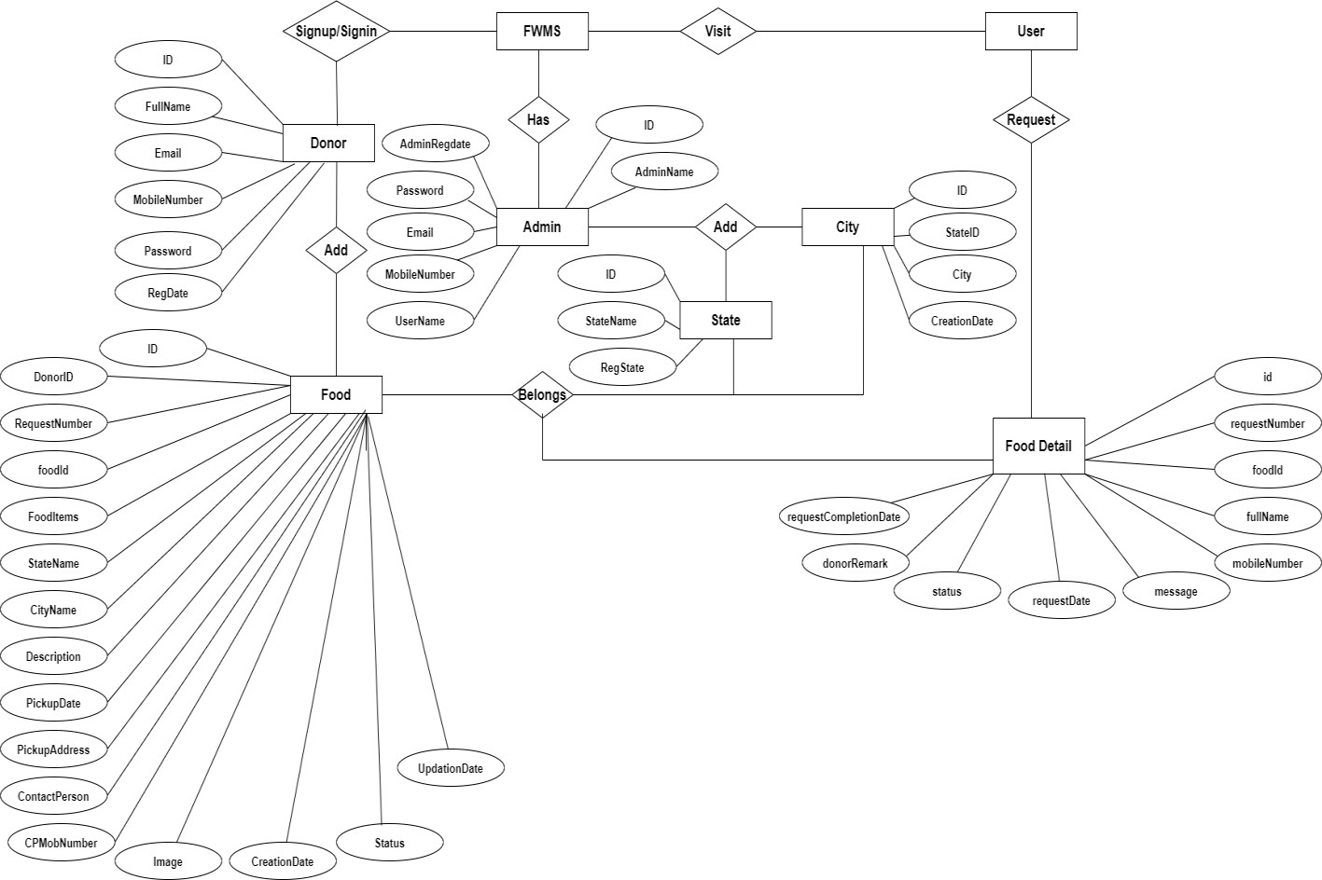Structured analysis is a set of tools and techniques that the analyst. To develop a new kind of a system:

o The traditional approach focuses on the cost benefit and feasibility analysis, project management, and hardware and software selection a personal consideration

**6.**

**DATABASE DESIGN**

The data in the system has to be stored and retrieved from database. Designing the

database is part of system design. Data

elements and data structures to be stored

have been identified at analysis stage. They are structured and put together to

design the data storage and retrieval system.

A database is a collection of interrelated data stored with minimum redundancy to

serve

many users quickly and efficiently. The general objective is to make database

access easy, quick, inexpensive and flexible for the user. Relationships are

established between the data items and unnecessary data items are removed.

Normalization is done to g

et an internal consistency of data and to have minimum

redundancy and maximum stability. This ensures minimizing data storage required,

minimizing chances of data inconsistencies and

optimizing for updates. The MySQL

database has been chosen for developing

the relevant databases.

•

**Food Waste**

**Management System (**

**FWMS**

**)**

**contains**

**8**

**MySQL**

**tables**

**:**

**tbl**

**admin**

**table Structure**

**:**

This table store the

admin login and personal Details

.

**tblcity**

**table Structure**

**:**

This table store

name of city

.

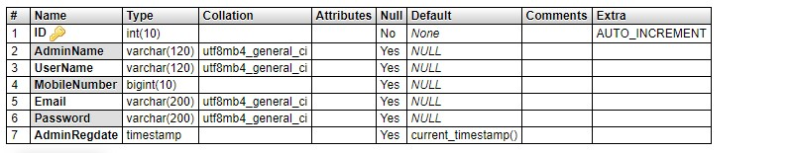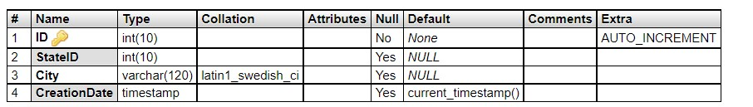

**tbl**

**state**

**table Structure**

**:**

This table store

name of state

.

**tbl**

**contact**

**table Structure**

**:**

This table store

the detail of contact us persons

.

**tbldonor table Structure**

**:**

This table store

the detail of food donor

.

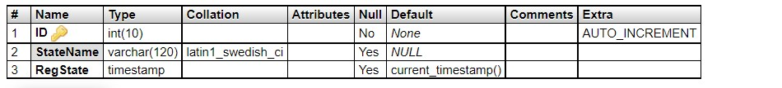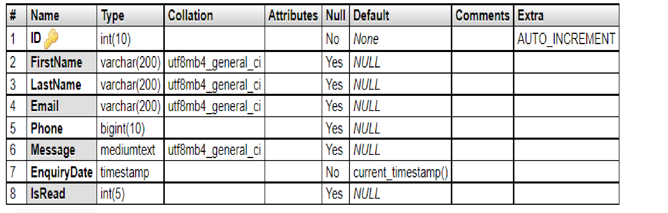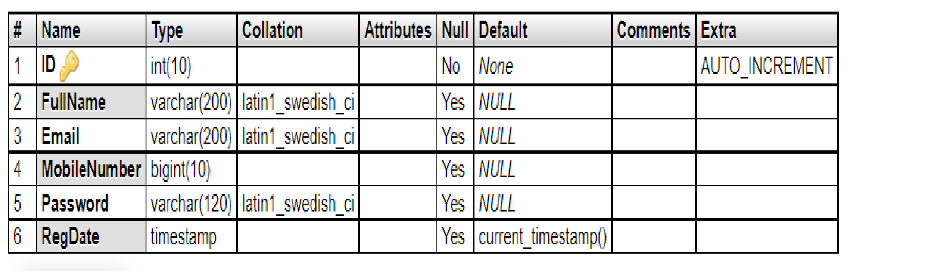

**tblfood table Structure**

**:**

This table store

the detail of donated food

.

**tblpages table Structure**

**:**

This table store

the detail of contact us and about us

.

**tblfoodrequests table Structure**

**:**

This table store

the detail of food request which is

send by

user

.

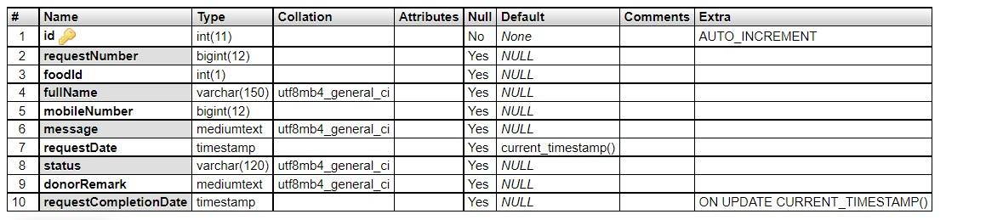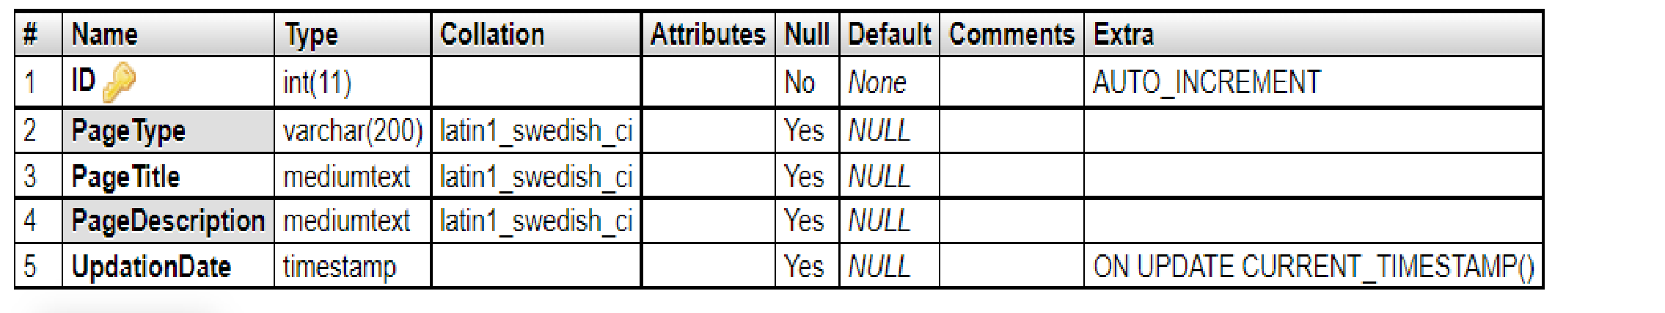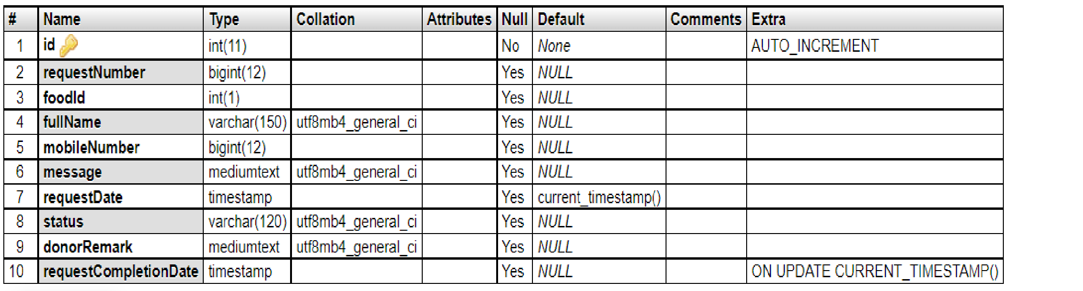

**Class Diagram:**

The class diagram shows a set of classes, interfaces, collaborations and their relationships.

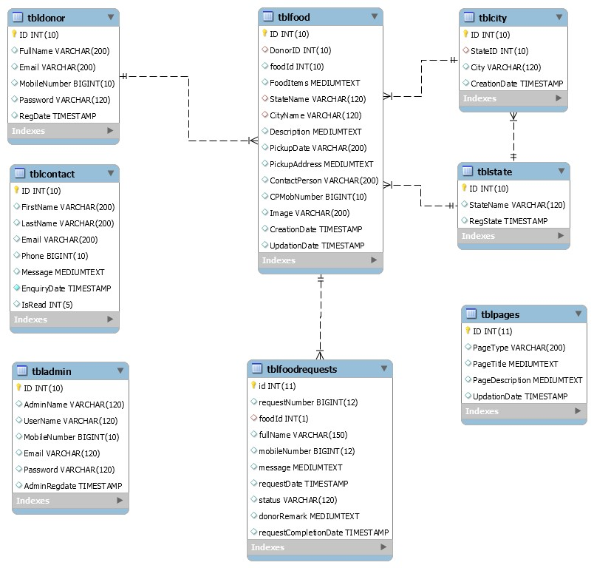

# 7. SYSTEM TESTING

• **SOFTWARE TESTING TECHNIQUES:**

Software testing is a critical element of software quality assurance and represents the ultimate review of specification, designing and coding. • **TESTING OBJECTIVES:**

* + Testing is process of executing a program with the intent of finding an error.
  + A good test case design is one that has a probability of finding an as yet undiscovered error.
  + A successful test is one that uncovers an as yet undiscovered error.These above objectives imply a dramatic change in view port. Testing cannot show the absence of defects, it can only show that software errors are present. There are three types of testing strategies:

1. Unit test
2. Integration test 3. Performance test
3. **Unit Testing:**

Unit testing focuses verification efforts on the smallest unit of software design module. The unit test is always white box oriented. The tests that occur as part of unit testing are testing the module interface, examining the local data structures, testing the boundary conditions, execution all the independent paths and testing error-handling paths.

1. **Integration Testing:**

Integration testing is a systematic technique or construction the program structure while at the same time conducting tests to uncover errors associated with interfacing. Scope of testing summarizes the specific functional, performance, and internal design characteristics that are to be tested. It employs top-down testing and bottom-up testing methods for this case.

1. **Performance Testing:**

Timing for both read and update transactions should be gathered to determine whether system functions are being performed in an acceptable timeframe.

# 8. CODING

```python

From tkinter import *

Import pymongo

# Connect to MongoDB database on the local host

Client = pymongo.MongoClient(‘mongodb://localhost:27017/’)

# Create a database and collection for storing the food waste data

Db = client[‘food_waste_management’]

Collection = db[‘food_waste’]

# Define functions to store and retrieve data Def add_food_waste():

Quantity = int(e_quantity.get())

Food_type = e_food_type.get()

Location = e_location.get()

# create a document to store in the collection

Food_waste = {“quantity”: quantity, “food_type”: food_type,”location”:

location}

# Add the document to the collection

Collection.insert_one(food_waste)

Update_total_label()

Def get_total_food_waste_by_location():

Location = e_location.get()

Food_waste = collection.find({“location”: location})

Total = 0

For fw in food_waste:

Total += fw[“quantity”]

Return total

Def update_total_label():

Total = get_total_food_waste_by_location()

Total_label.configure(text=f’Total Food Wasted: {total} kg’)

# Create the Tkinter user interface

Root = Tk()

Root.title(“Food Waste Management System”)

Root.geometry(“400x300”)

# Define labels and entry fields

Quantity_label = Label(root, text=”Quantity”)

Quantity_label.place(x=10, y=20)

E_quantity = Entry(root)

E_quantity.place(x=100, y=20)

Food_type_label = Label(root, text=”Food Type”)

Food_type_label.place(x=10, y=60)

E_food_type = Entry(root)

E_food_type.place(x=100, y=60)

Location_label = Label(root, text=”Location”)

Location_label.place(x=10, y=100)

E_location = Entry(root)

E_location.place(x=100, y=100)

Total_label = Label(root, text=”Total Food Wasted: 0 kg”)

Total_label.place(x=10, y=200)

# Define buttons to add food waste and update total label

Add_button = Button(root, text=”Add Food Waste”, command=add_food_waste)

Add_button.place(x=10, y=150)

Update_button = Button(root, text=”Update Total”, command=update_total_label)

Update_button.place(x=150, y=150)

# Start the Tkinter event loop

Root.mainloop()

```

In the above code, we define a user interface using Tkinter that includes entry fields for the quantity, food type, and location of the food waste data, as well as

buttons to add new data and update the total waste for a specific location. The ‘add_food_waste’ function will store the food waste data as a document in the MongoDB ‘food_waste’ collection, while the

‘get_total_food_waste_by_location

# 9. OUTPUT SCREEN OF PROJECT

**Home Page:**

**Contact Us:**

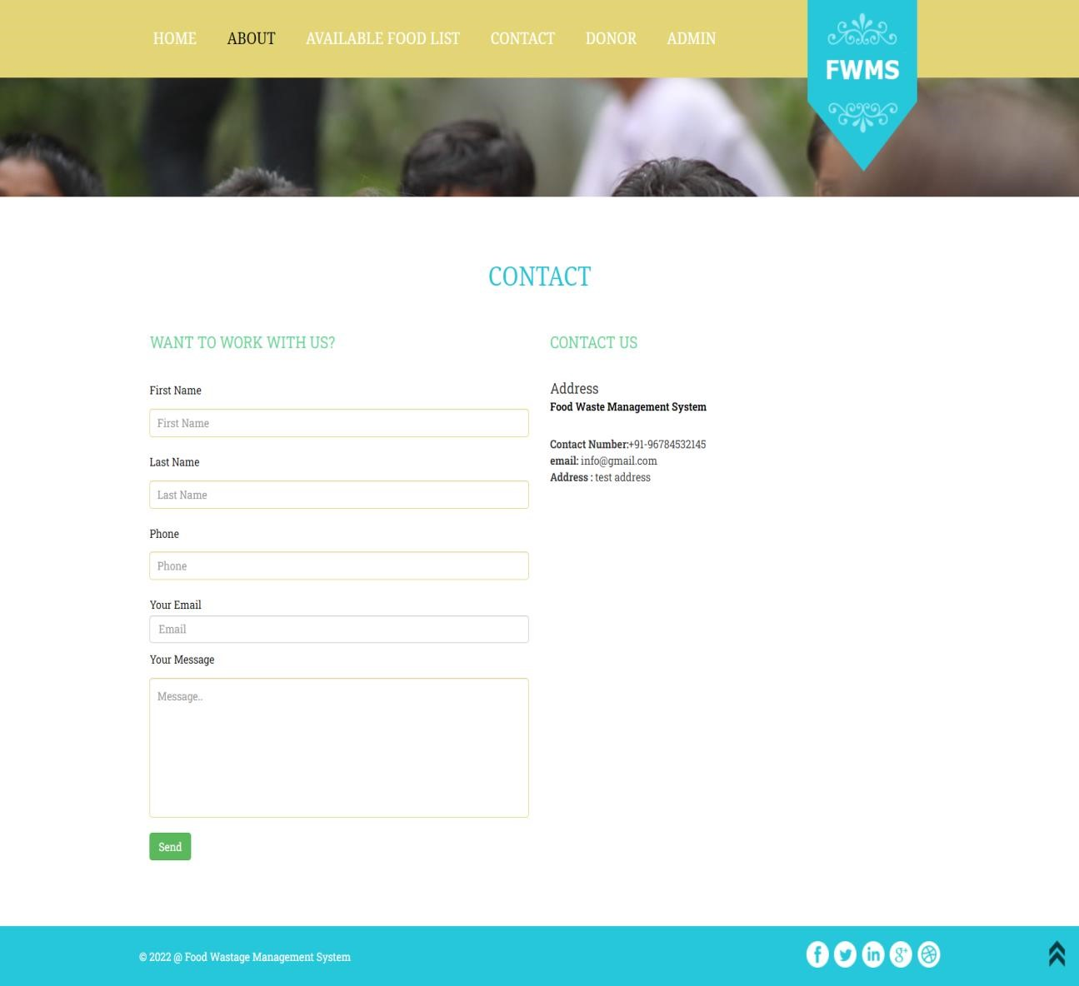

**About Us:**

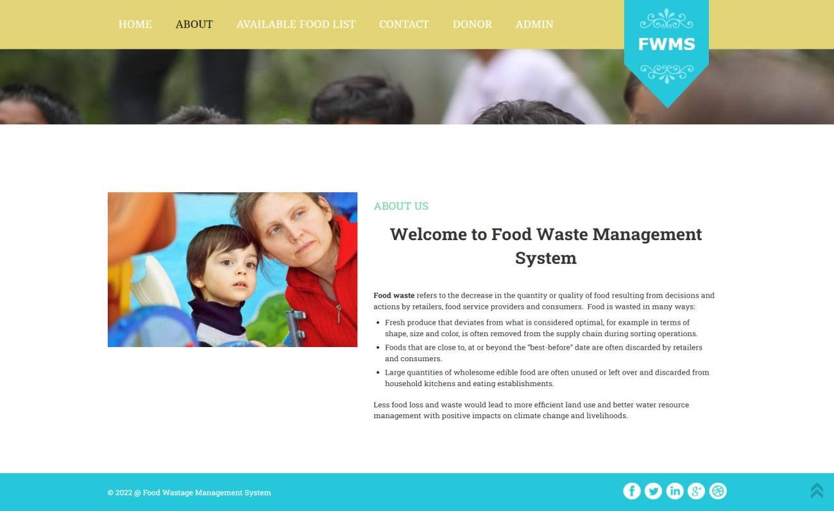

**Available Food List:**

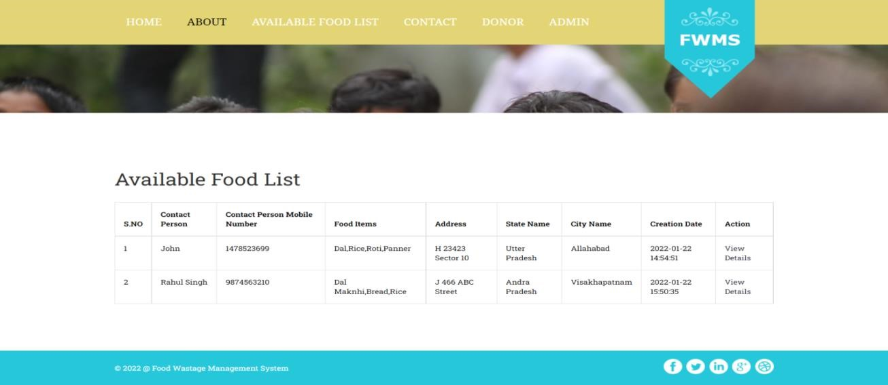

**View Detail of Food List:**

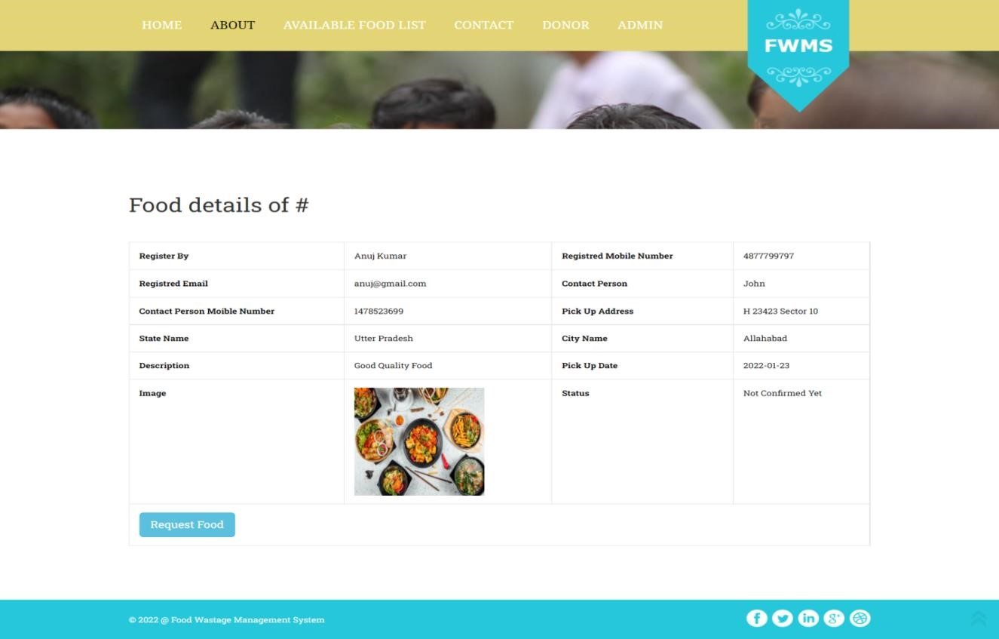

**Admin Login:**

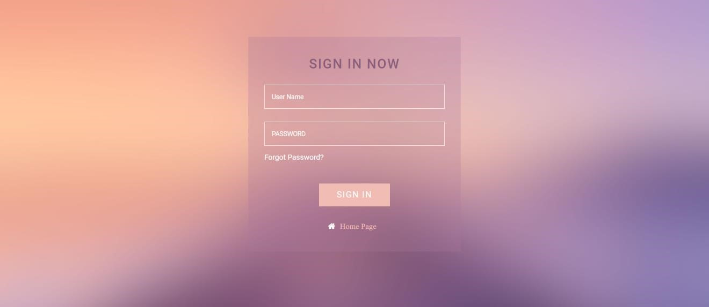

**Forgot Password:**

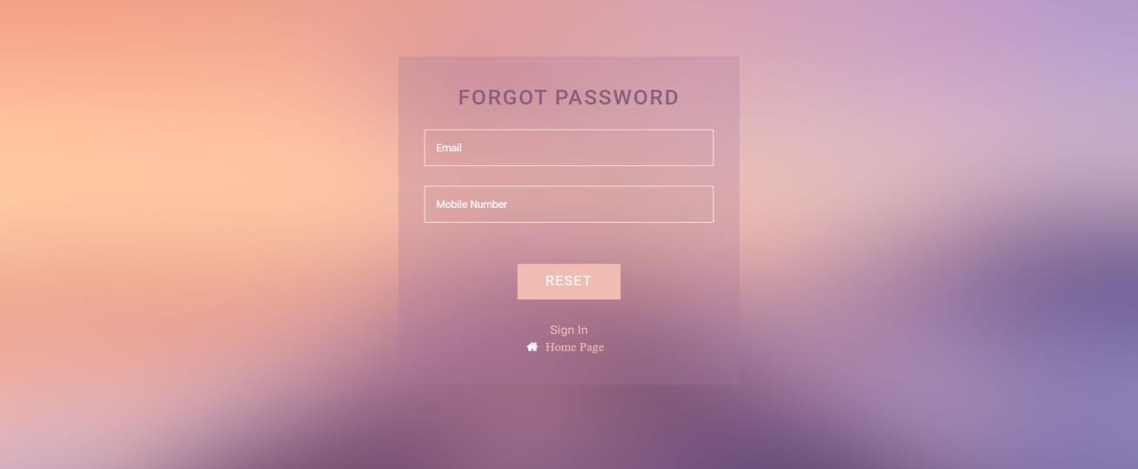

**Reset Password:**

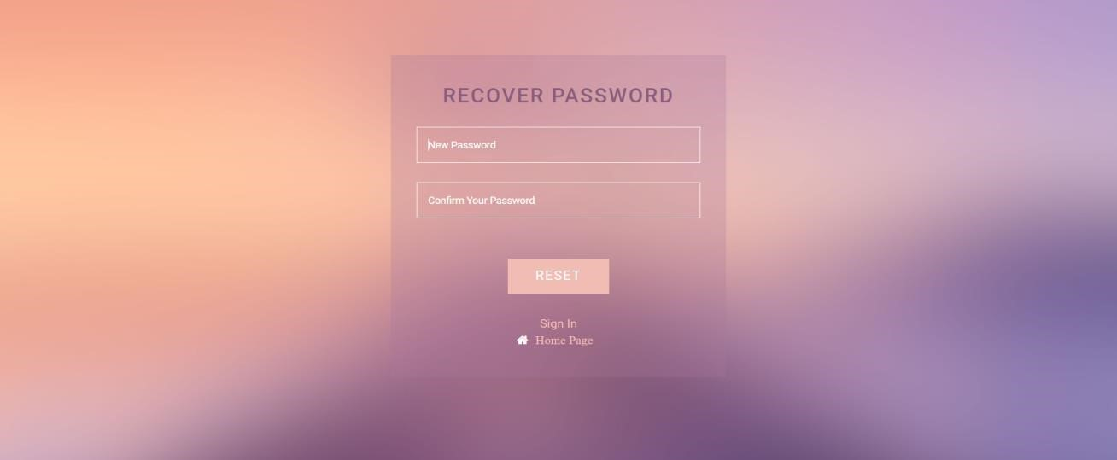

**Dashboard:**

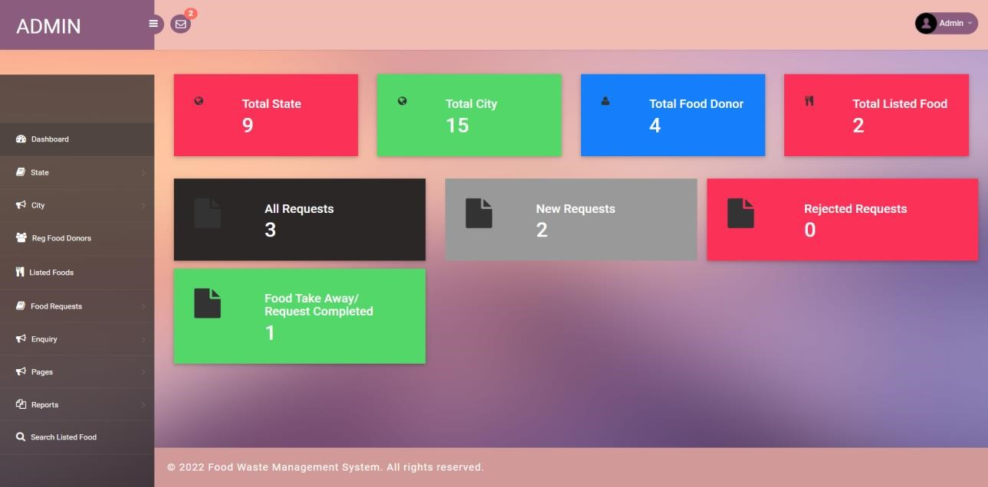

**Profile:**

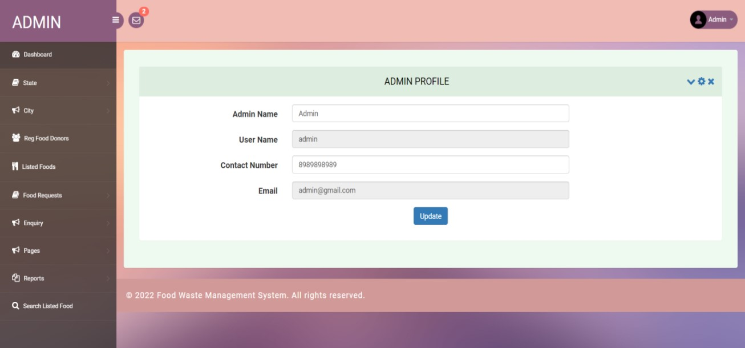

**Change Password:**

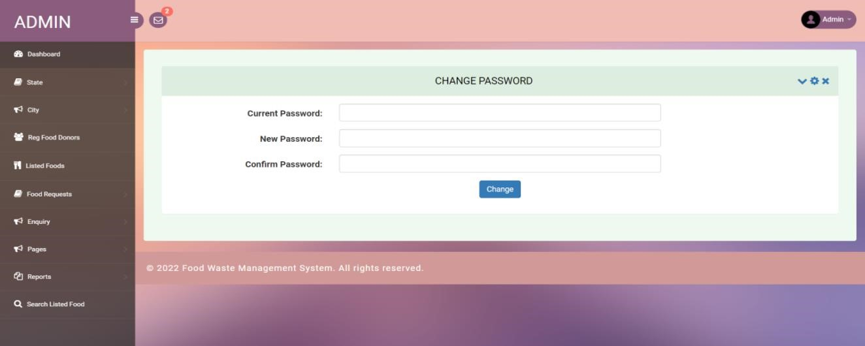

**Add State:**

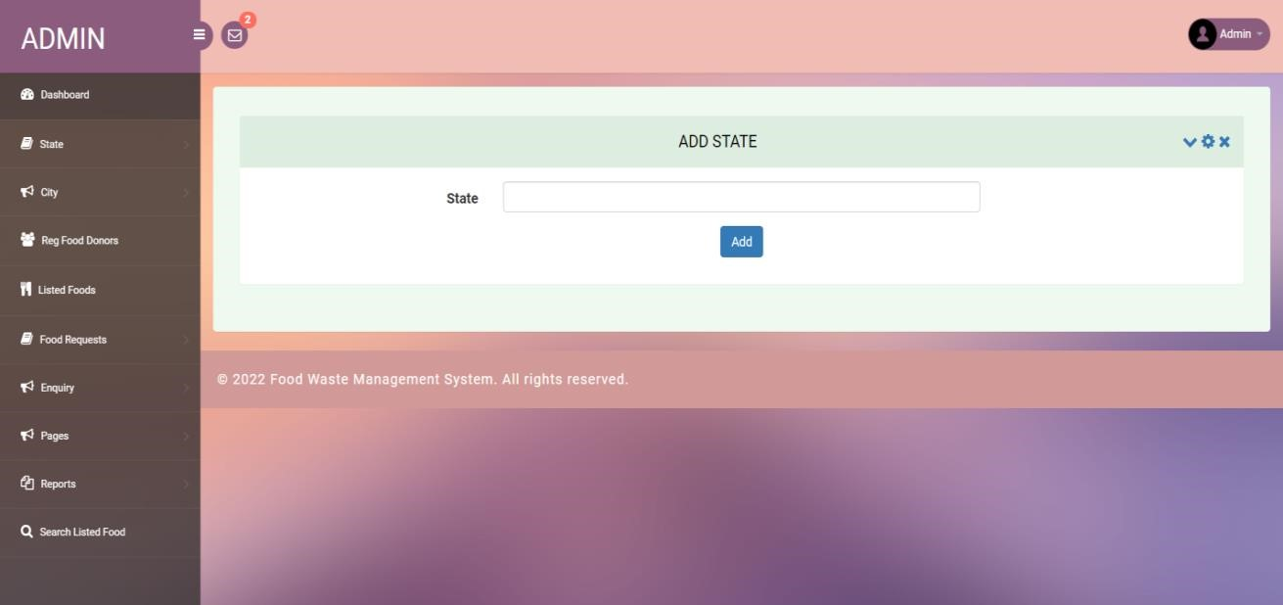

**Manage State:**

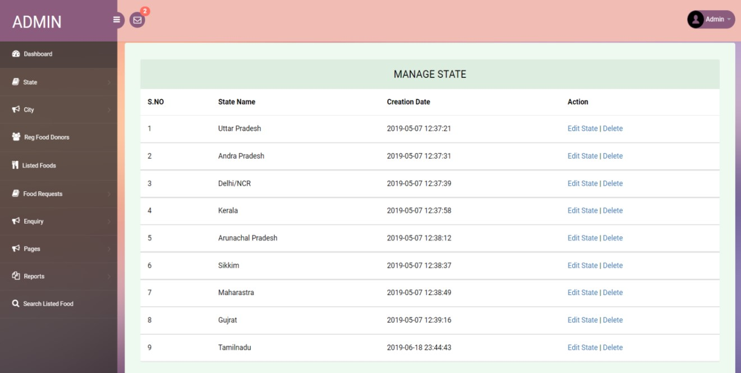

**Update State:**

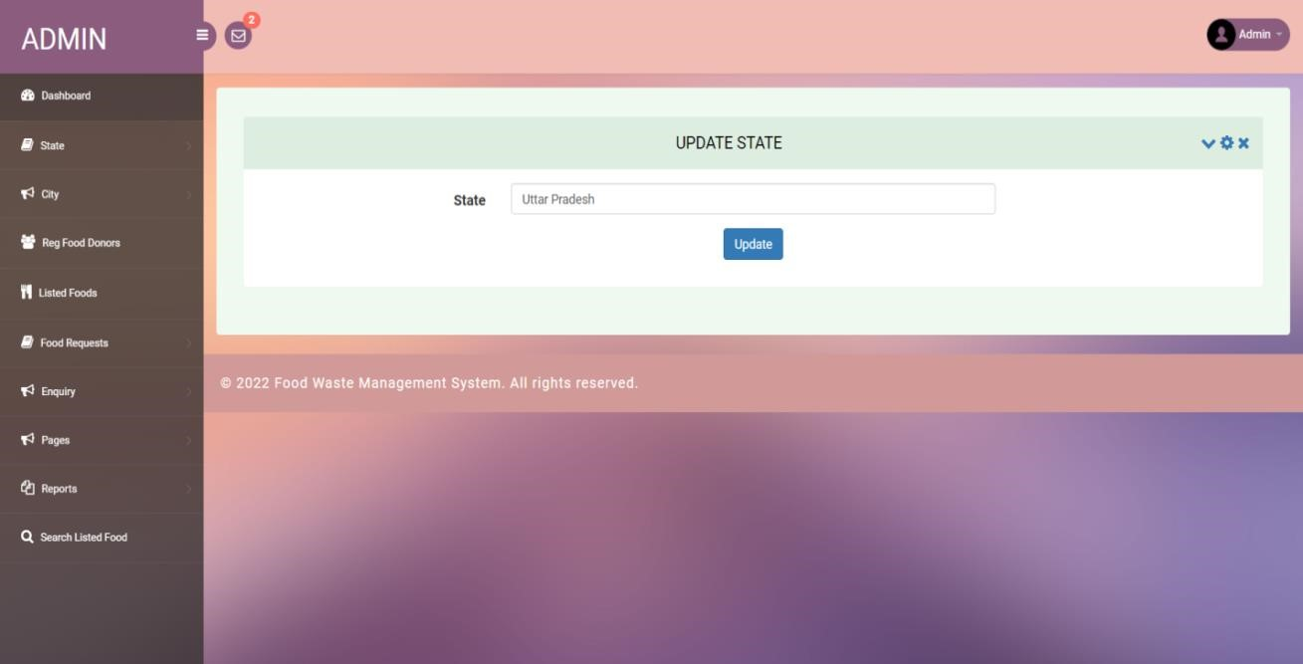

**Add City:**

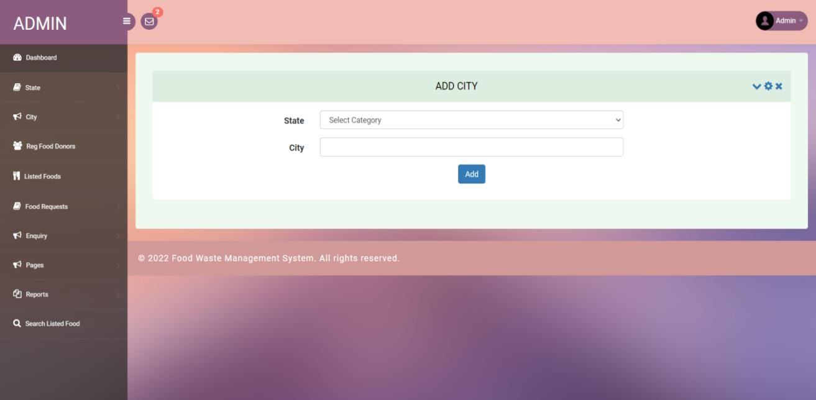

**Manage City:**

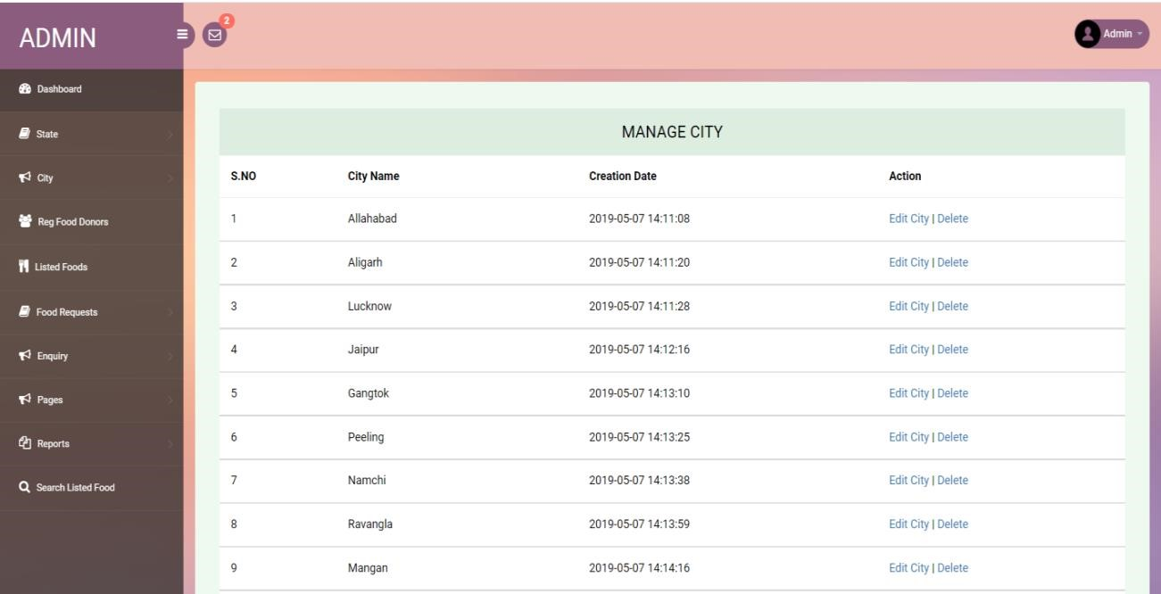

**Update City:**

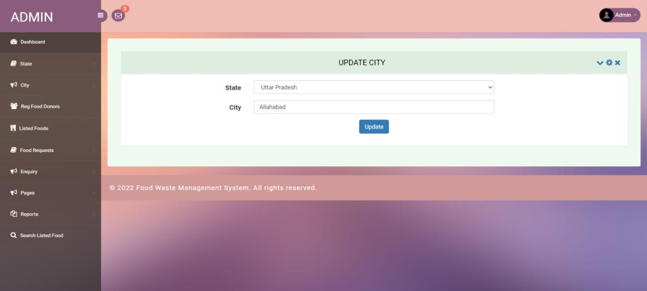

**Registered Food Donor:**

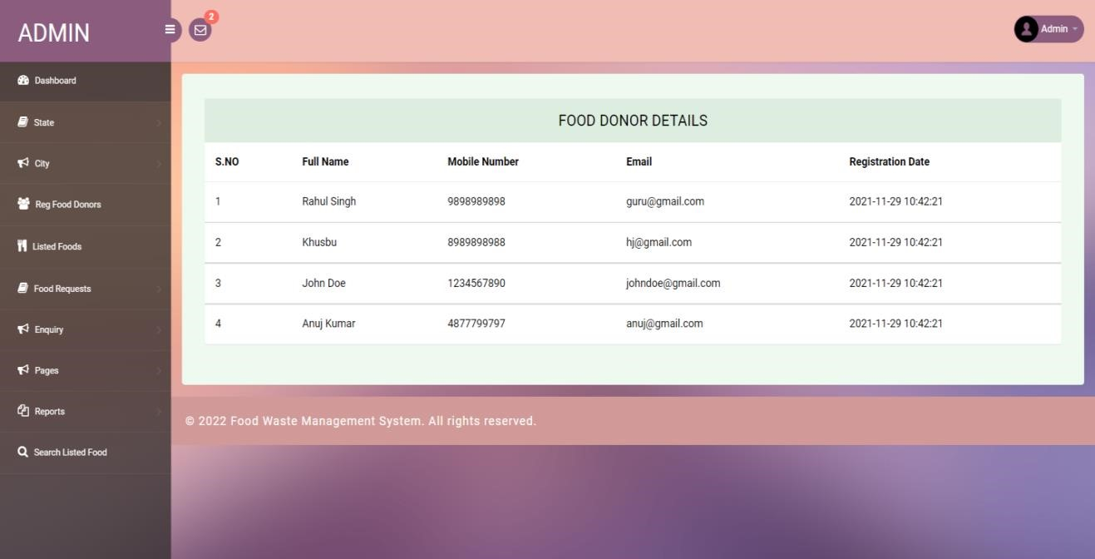

**Listed Food:**

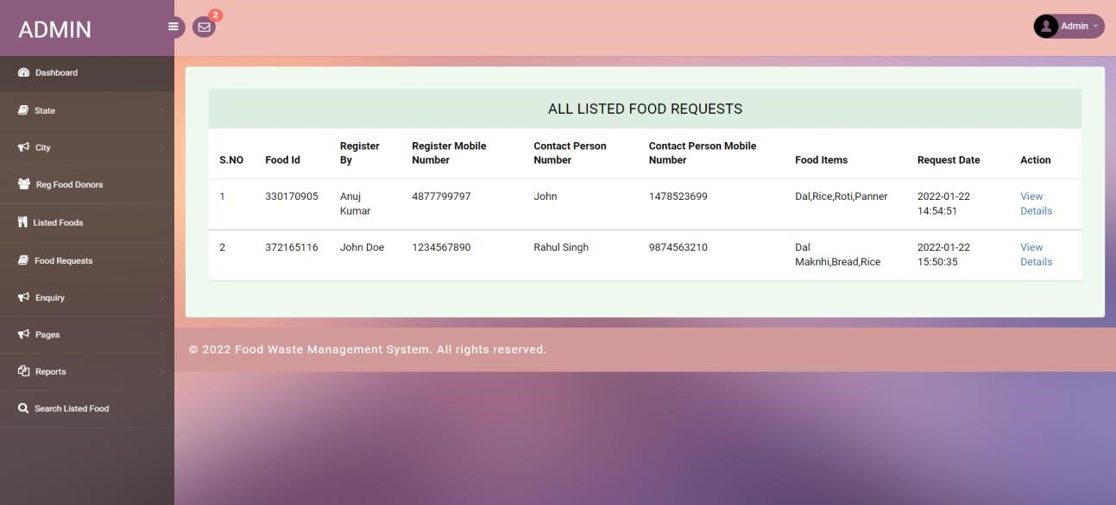

**View Listed Food Detail:**

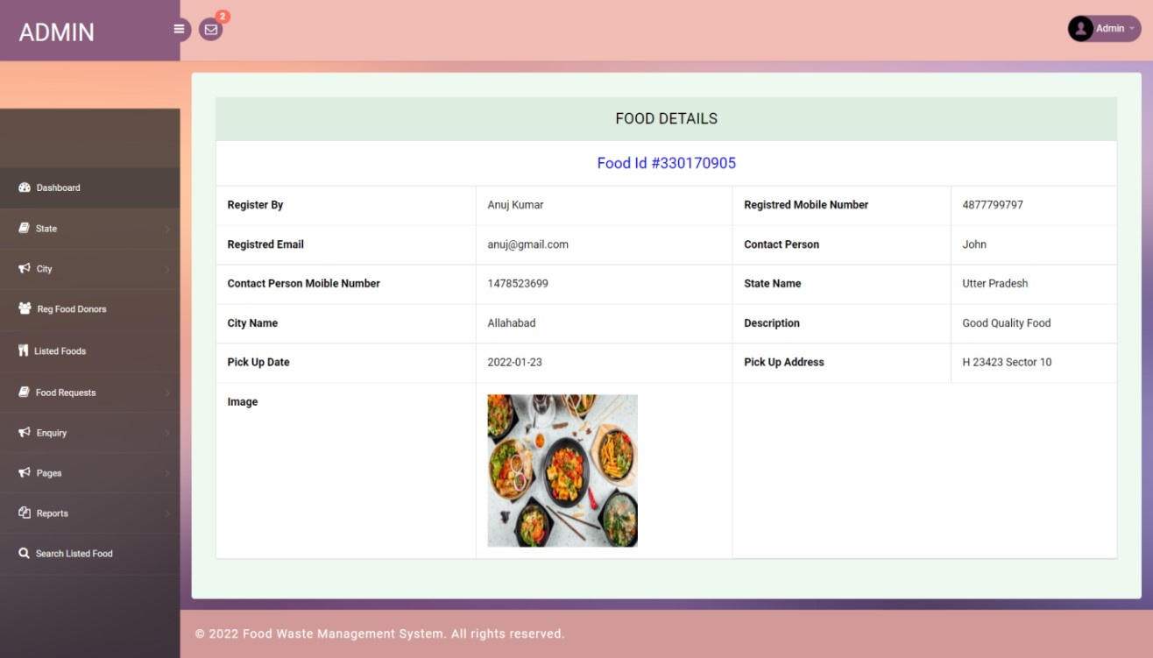

**New Food Request:**

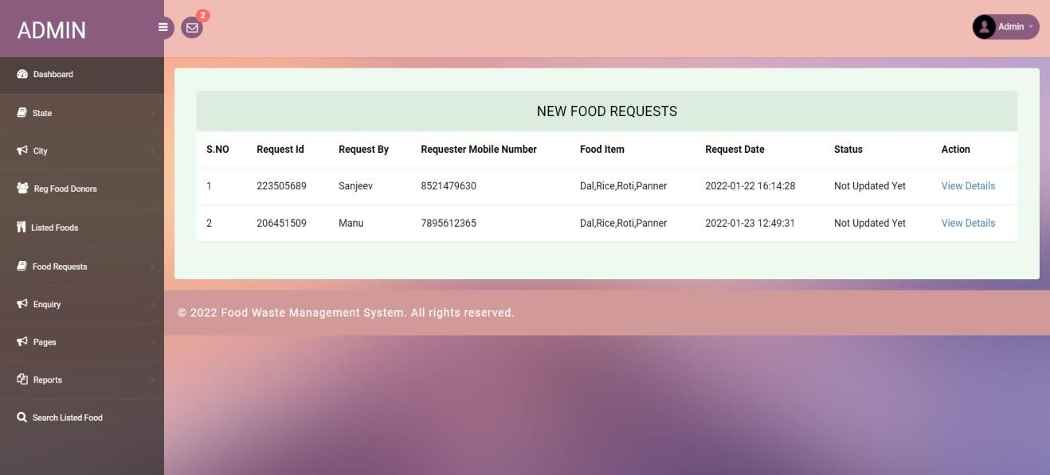

**Detail of Food Request:**

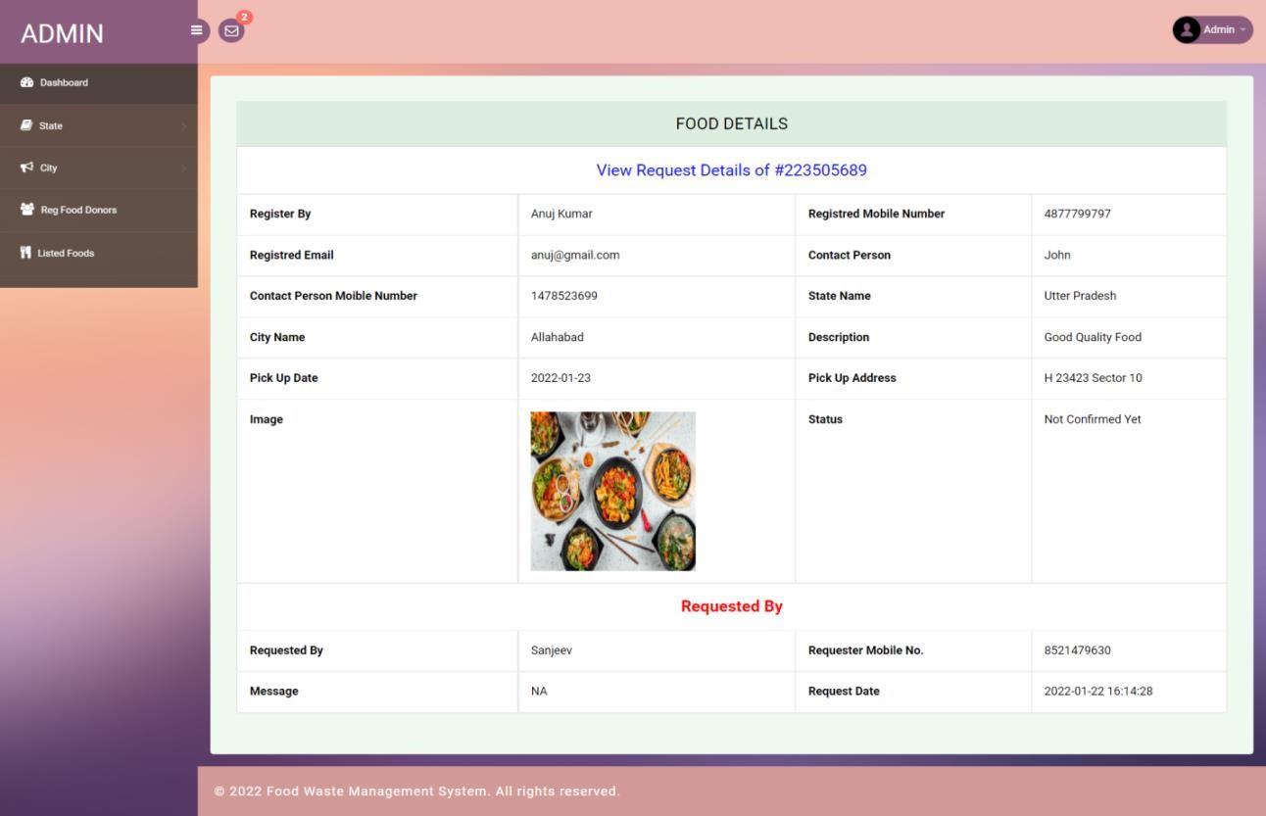

**Unread enquiry:**

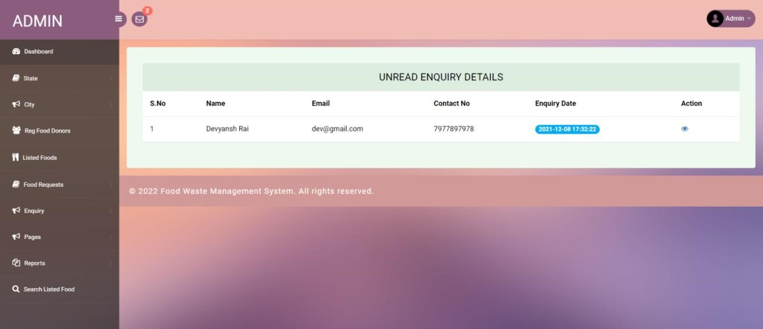

**View unread enquiry:**

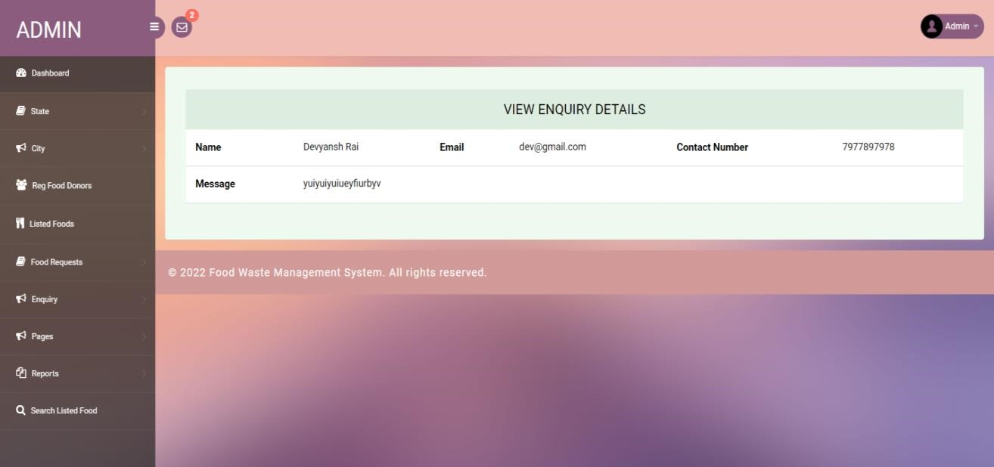

**About us page:**

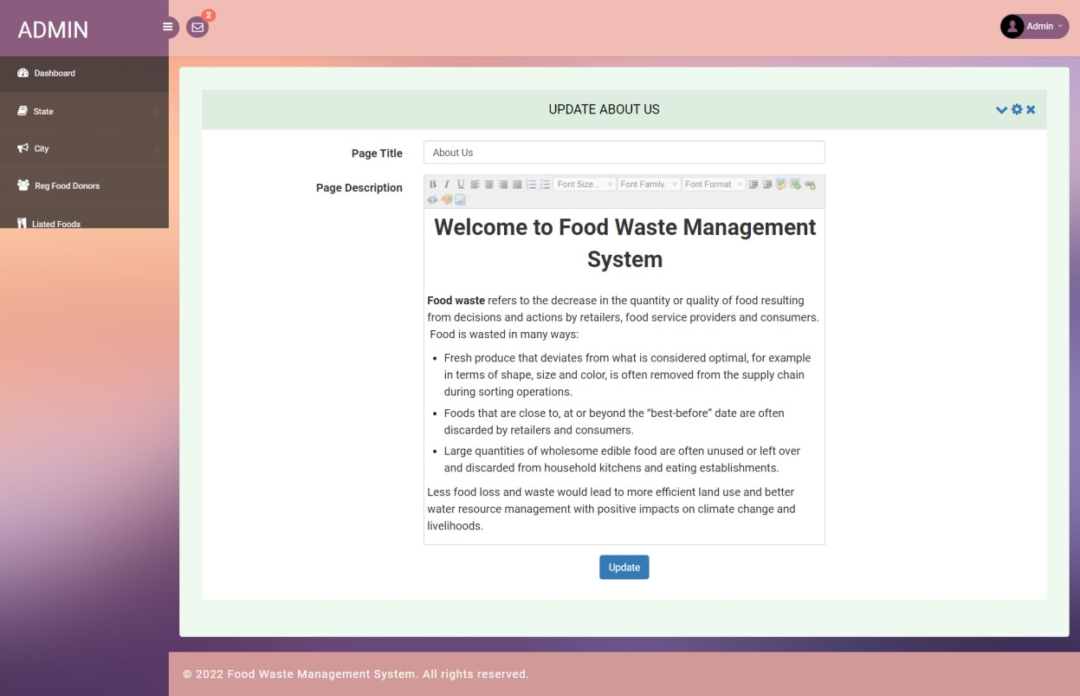

**Contact Us Page:**

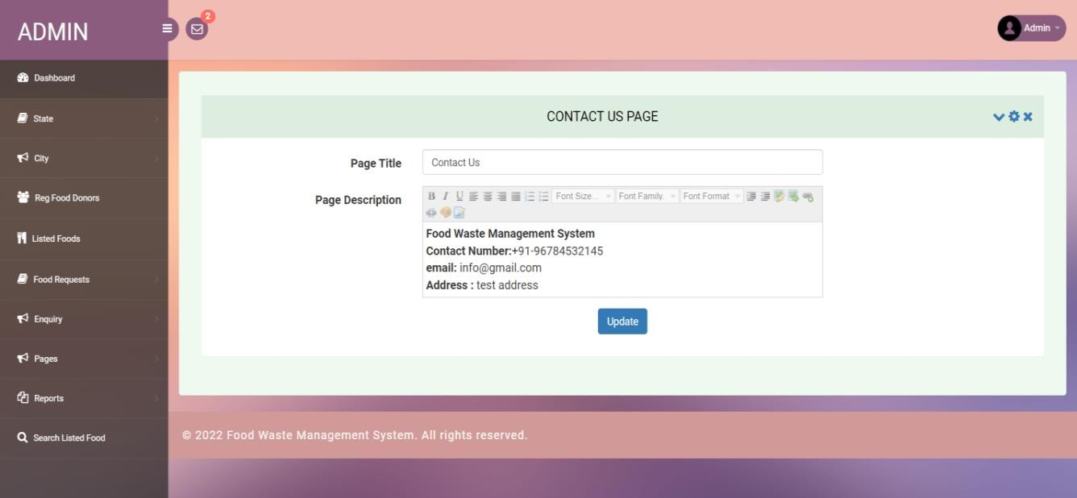

**Report of donated food:**

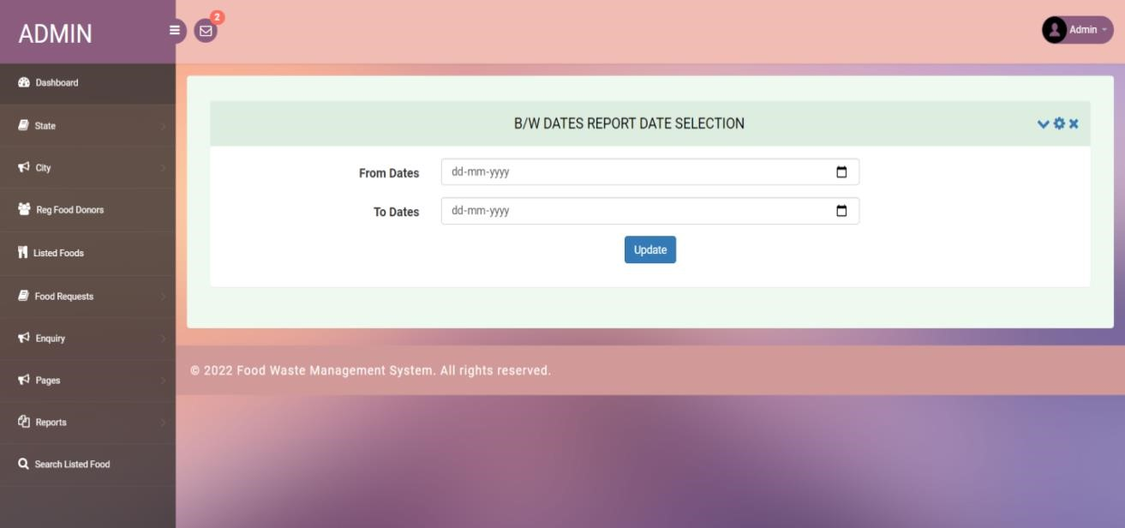

**View report of donated food:**

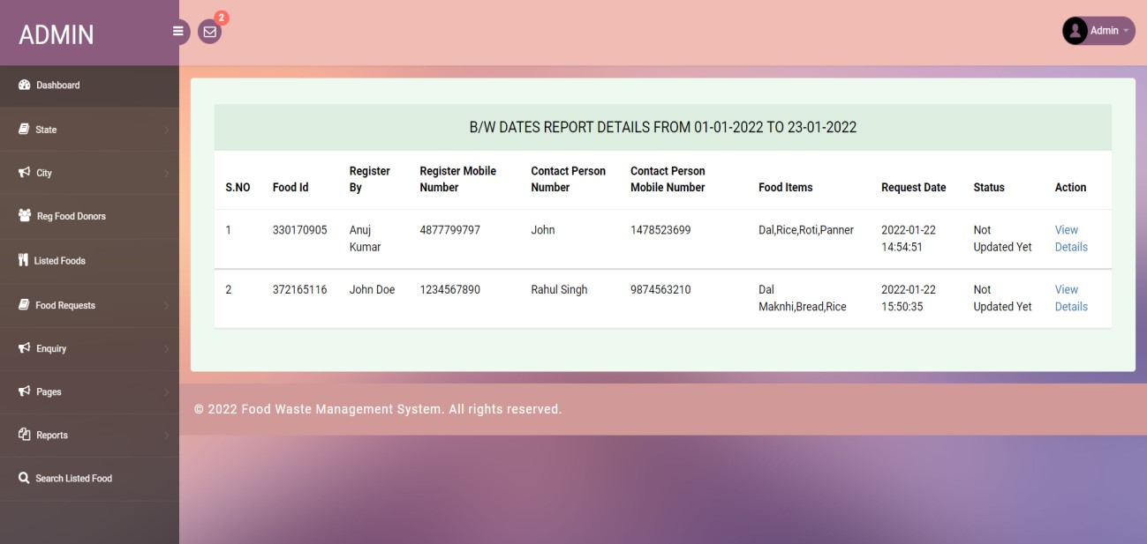

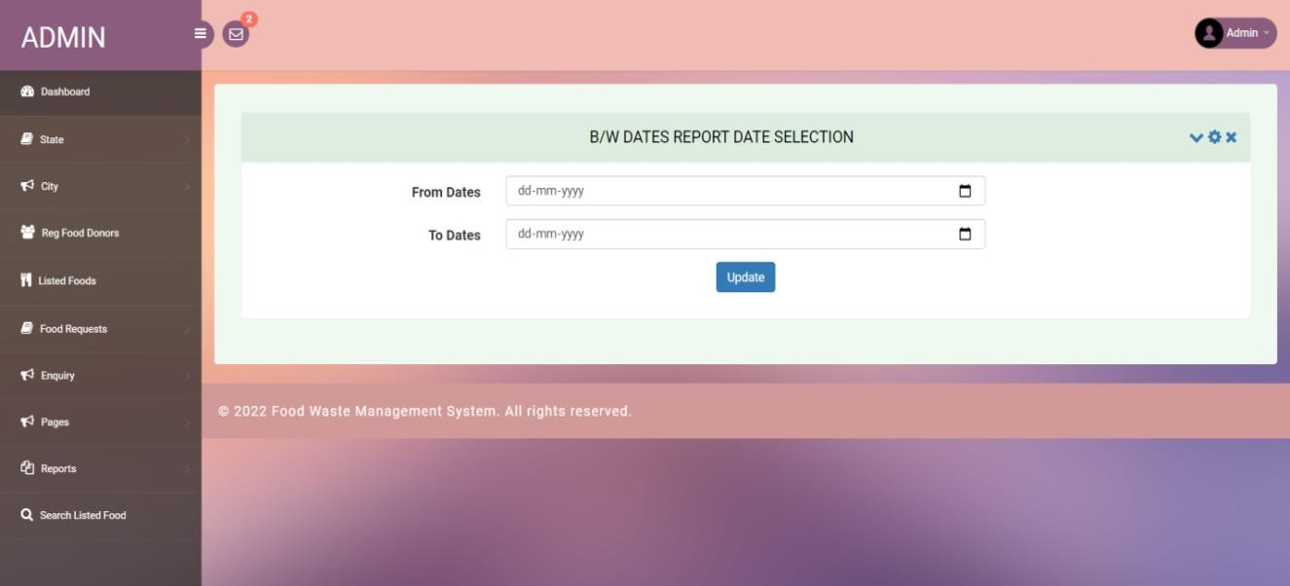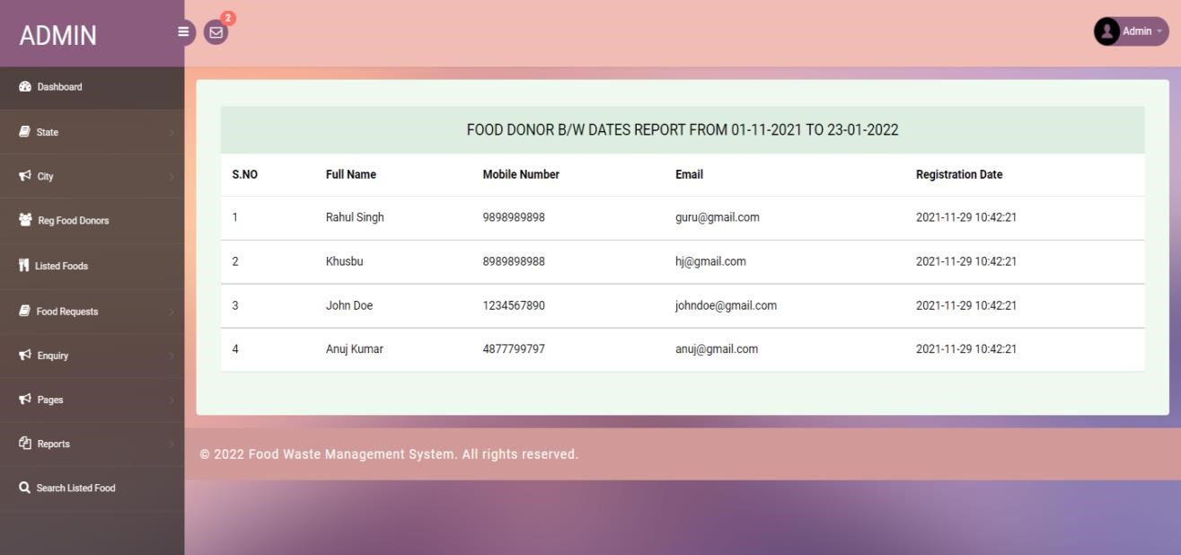**Report of food donor:**

**View report of food donor:**

**Search:**

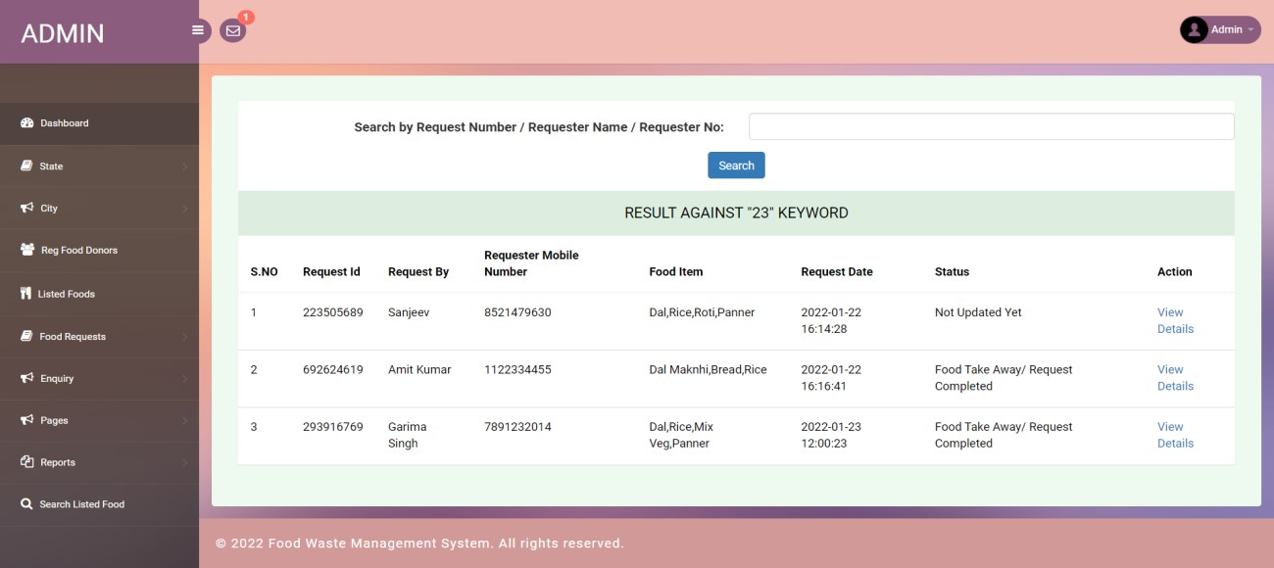

**Food Donor Login:**

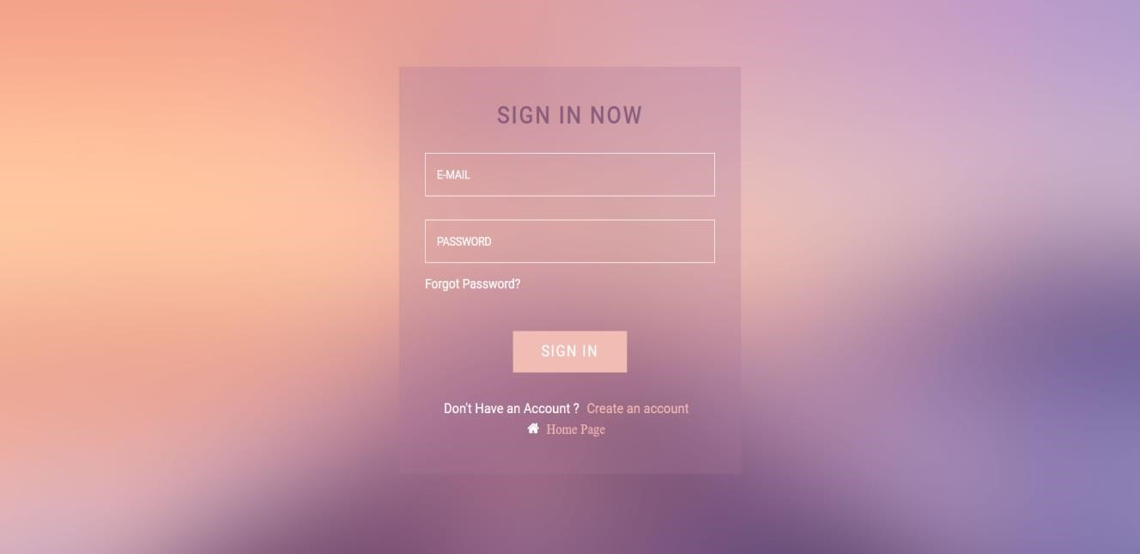

**Registration Page:**

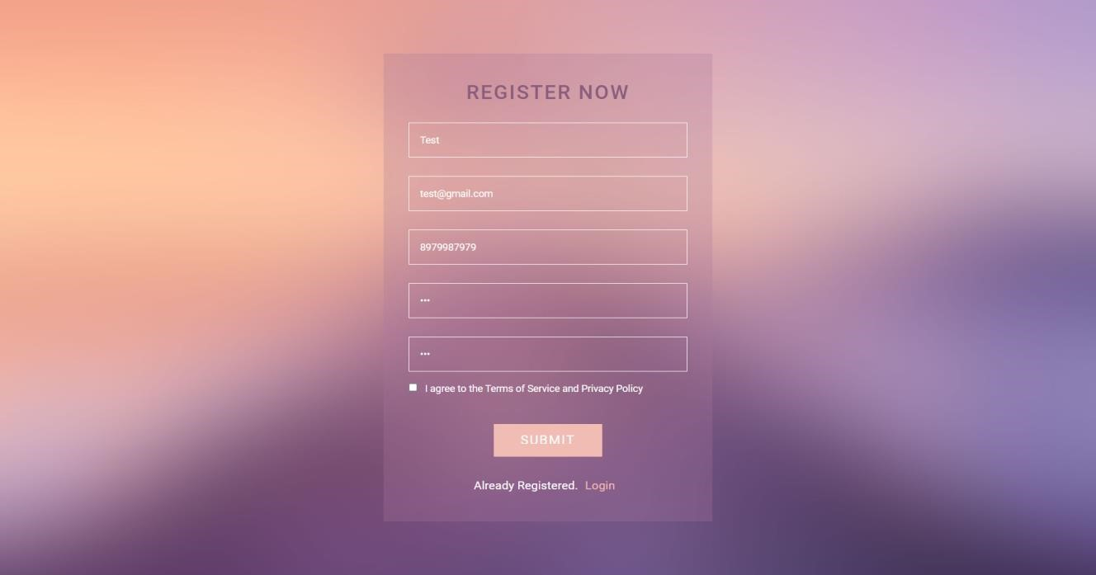

**Dashboard:**

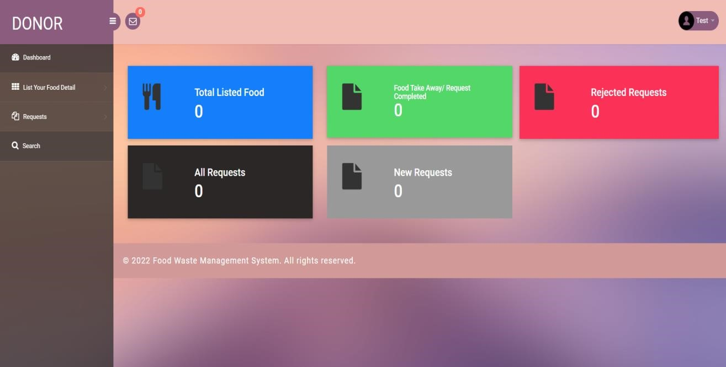

**Add Food:**

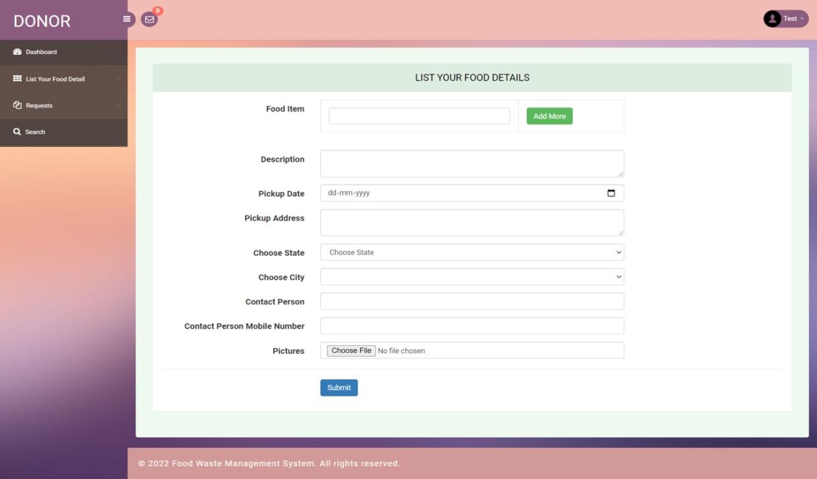

**Manage Food**

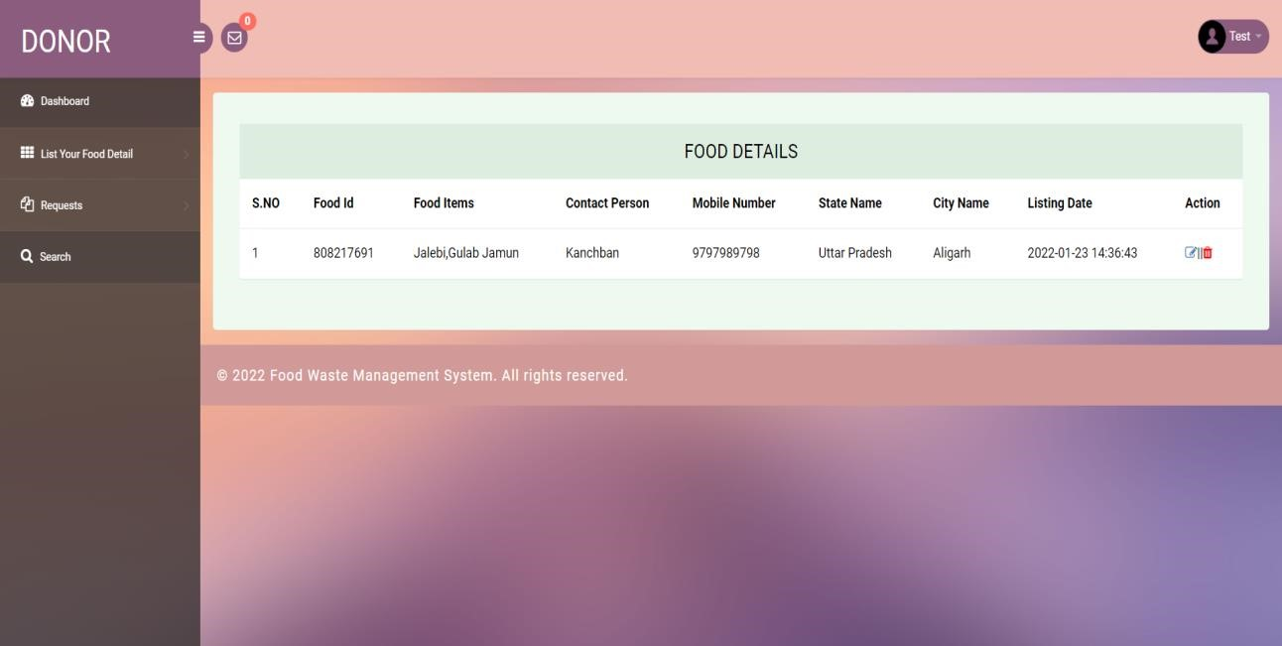

**Update Listed Food:**

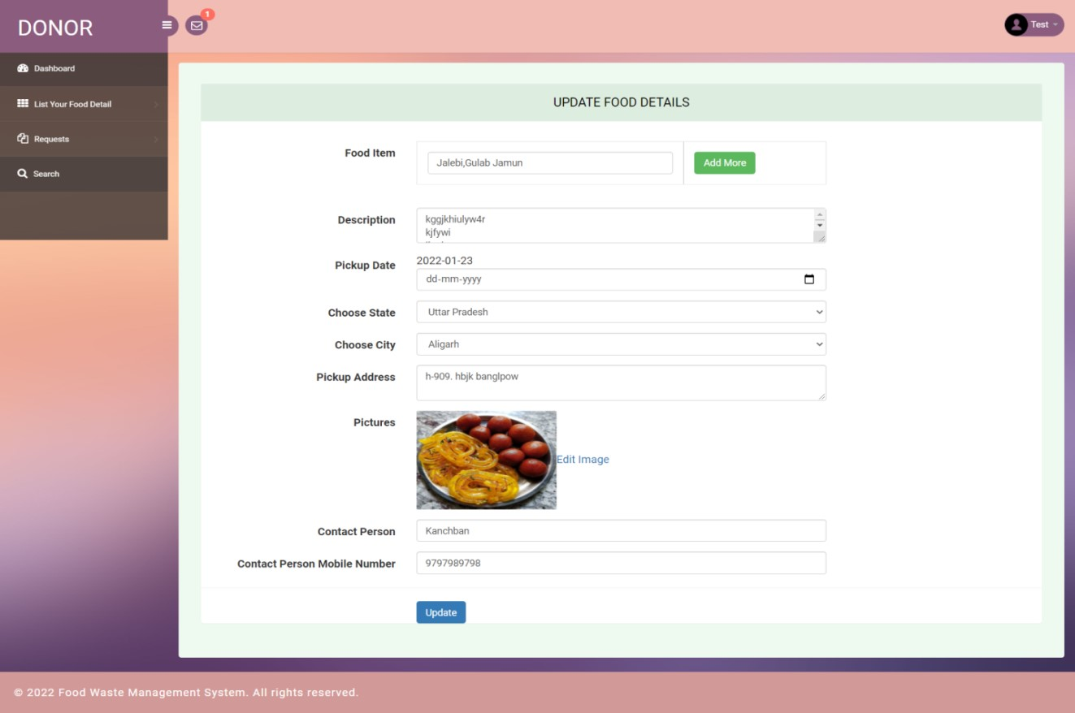

**Update Image:**

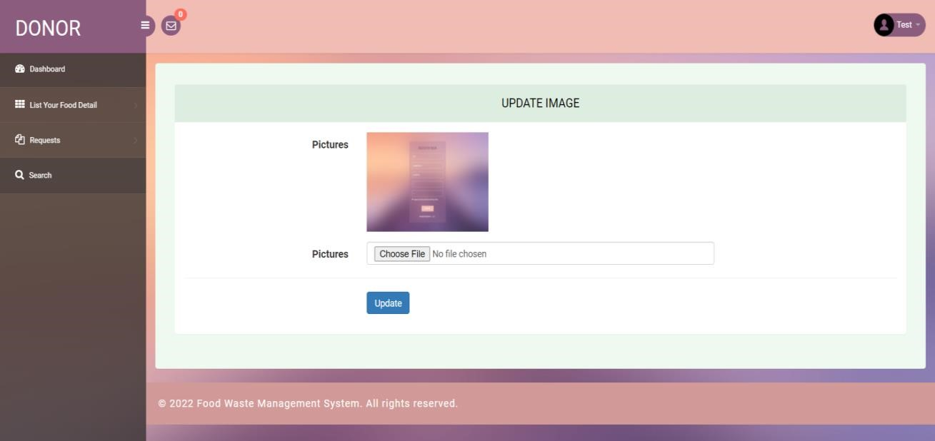

**New Food Request:**

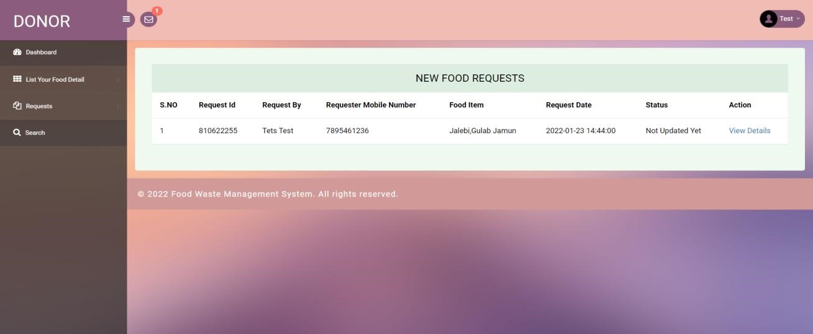

**View new food request:**

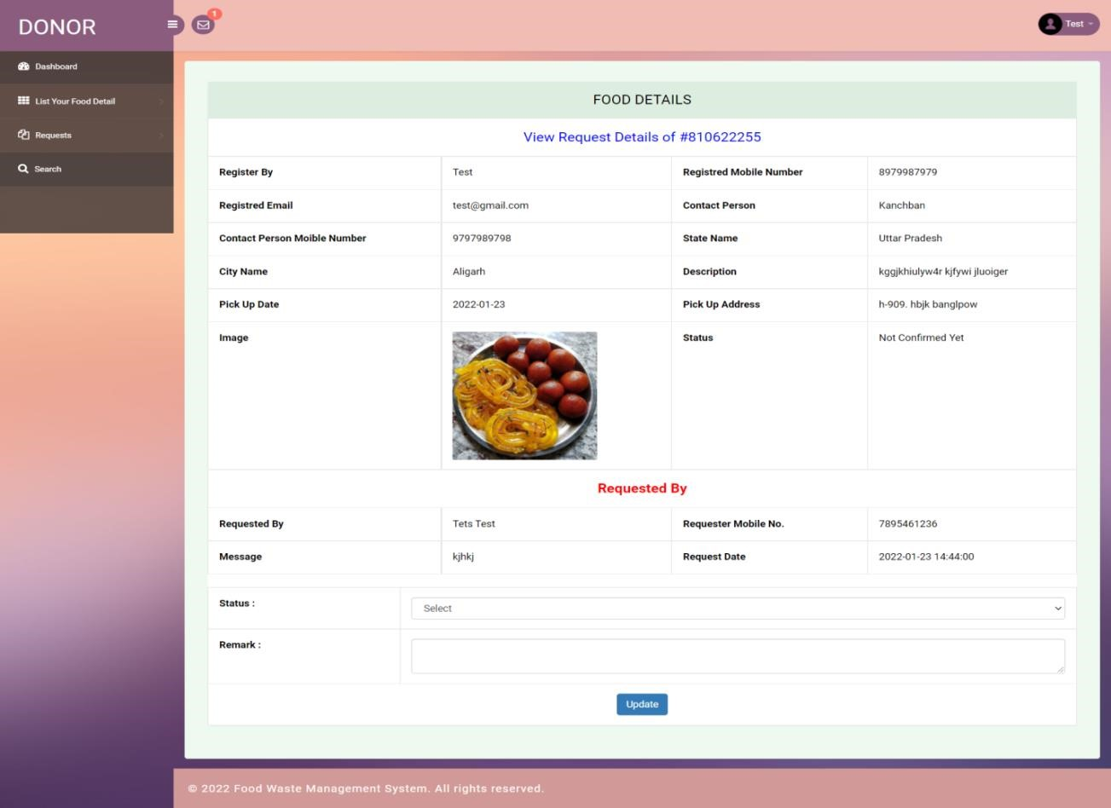

**Search:**

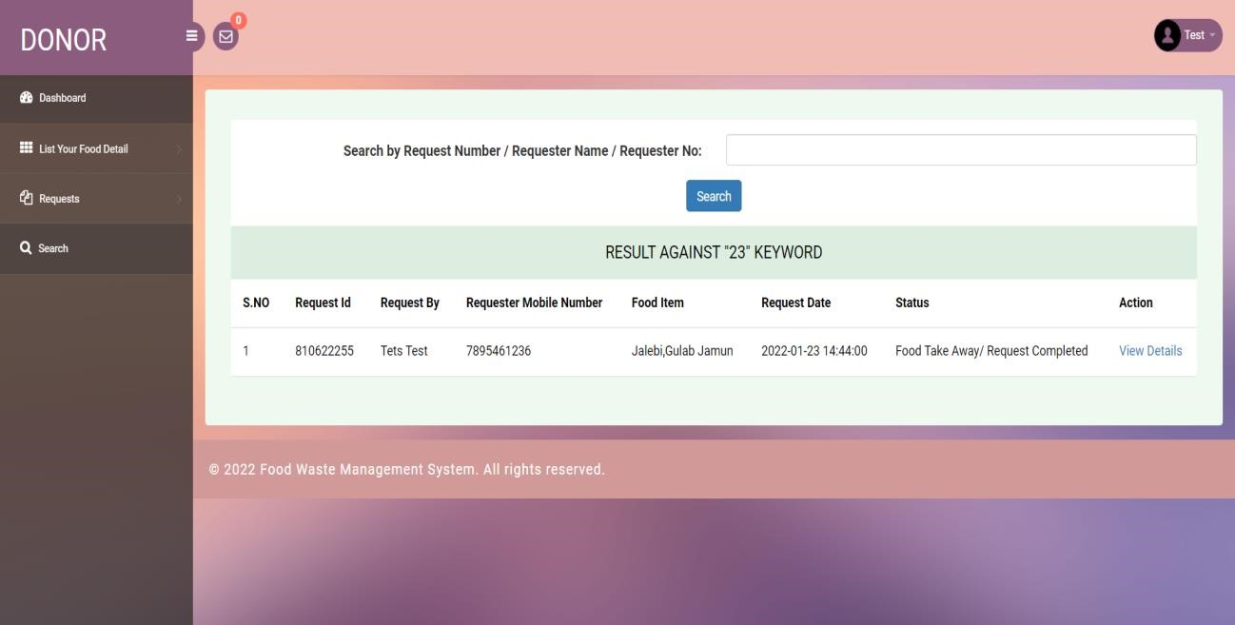

# 10. CONCLUSION

The project titled as **Food Wastage Management System** was deeply studied and analyzed to design the code and implement. It was done under the guidance of the experienced project guide. All the current requirements and possibilities have been taken care during the project time.

In our project, we are targeting the person who wants to donate wastage food this will create a greater impact on the cost saving as well as the food wastage management system, and there will be greater impact on the day-by-day food wastage. In our future work, we will try to integrate with other emerging technology such as block chain and also it will cover more areas.

# 11. BIBLLIOGRAPHY

* **For PHP** 
  + <https://www.w3schools.com/php/default.asp>
  + <https://www.sitepoint.com/php/>
  + <https://www.php.net/>
* **For MySQL** 
  + <https://www.mysql.com/>
  + [http://www.mysqltutorial.org](http://www.mysqltutorial.org/)
* **For XAMPP** 
  + <https://www.apachefriends.org/download.html>